Q1]Create an html page with 5 separate text lines in different sizes and different colours. State size of each line in its text.

**CODE:**

<html>

<head>

  <title> Different font size </title>

</head>

<body>

  <font size="6" color="yellow">text size is 6 and colour is yellow</font><br>

  <font size="2" color="blue">text size is 2 and colour is blue</font><br>

  <font size="1" color="green">text size is 1 and colour is green</font><br>

  <font size="5" color="red">text size is 5 and colour is red</font><br>

  <font size="7" color="black">text size is 7 and colour is black</font><br>

</body>

</html>

Q2] Create an html page with all the different text styles(bold, italic and underline)and their combination on separate lines. State style of each line in its text.

**CODE:**

<html>

<head>

<title> Assignment 1-Q3 </head>

</title>

<body bgcolor="purple">

<center>

<h1>Assignment-1</h1><br>

<b> first line with bold letter </b><br>

<u> second line with underline letter </u><br>

<i> third line with italic letter </i><br>

<b><i><u> forth line with bold,italic and underline </b></i></u></br>

</centre>

</body>

</html>

Q3] Create an html page with following specifications :

Title should be about my college

Place your college name at the top of the page in large text followed by             address in smaller size

Add names of courses offered each in a different color, style and typeface

Add scrolling text with a message of your choice Add a college image at the bottom

**CODE:**

<html>

<head>

  <title>MY COLLEGE</title>

</head>

<body bgcolor="skyblue">

  <font style="color:purple; font-family: algerian;font-size: 30px

;"><center><h1>MIT WORLD PEACE UNIVERSITY</h1></center></font><br>

  <font style="comic sans ms" color="black">paud road,Kothrud,Pune-

411038</font><br><br>

  LISTS OF COURSE OFFERED BY THE UNIVERSITY:

  <ul type="disc">

<font style="comic sans ms" color="yellow"><li>BCA</li></font>

  <font style="arial" color="green"><li>MCA</li></font>

  <font style="calibri" color="pink"><li>BSc</li></font>

  <font style="cambria" color="forest blue"><li>MSc</li></font>

  </ul>

  <marquee behaviour="scroll" bgcolor="white" direction="right">Admissions are open:) APLLY NOW!!</marquee><br><br>

  <img src="mit.jpg" alt="error" height="300" width="500">

</body>

</html>

Q4.Program to figure whether the number is even or odd.

Code:

<?php

$a=123456;

if($a%2==0)

{

    echo "123456 is even";

}

else{

    echo "123456 is odd";

}

?>

Q5- program to determine prime number

Code:

<?php

function primenum($num)

{

    if($num == 1)

    return 0;

    for($i=2; $i<=$num/2; $i++)

    {

        if ($num%$i==0)

        return 0;

    }

    return 1;

}

$num=47;

$flag=primenum($num);

if($flag==1)

6. Write a program area of triangle to calculate base as 10 & height as 15

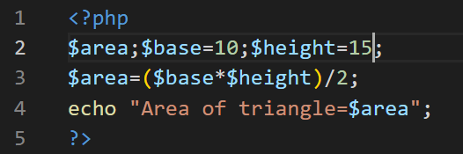

7. Write down the program to draw a pattern

AAAAA

BBBB

CCC

DD

E

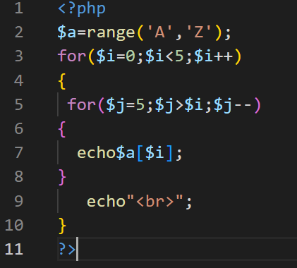

8.Create a HTML form that accept the user name and display the name using PHP.

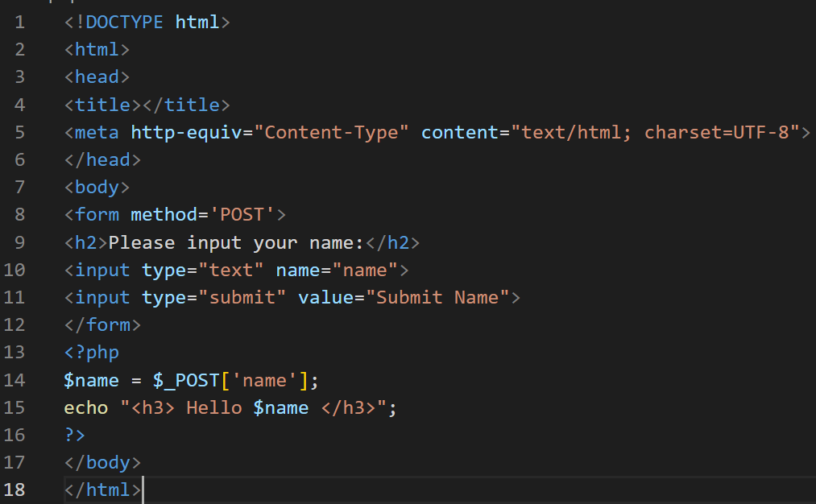

Q9.Write a PHP script which will display the Cars in the following way using array

* BMW
* Dastun
* Honda

<?php

$color = array('Dastun', 'Honda', 'BMW');

foreach ($color as $c)

{

echo "$c, ";

}

sort($color);

echo "<ul>";

foreach ($color as $y)

{

echo "<li>$y</li>";

}

echo "</ul>";

?>

Q10] Write a PHP script to get first element of the above array

**INPUT:**

<?php

$color = array(4 => 'coffee', 6 => 'green', 11=> 'red');

echo reset($color)."\n";

?>

Q11] Write a php script that inserts a new item in an array in  any position

**INPUT:**

<?php

$original = array( '1','2','3','4','5' );

echo 'Original array : '."\n";

foreach ($original as $x)

{echo "$x ";}

$inserted = '$';

array_splice( $original, 3, 0, $inserted );

echo " \n After inserting '$' the array is : "."\n";

foreach ($original as $x)

{echo "$x ";}

echo "\n"

?>

Q12] Write a php script to convert lowercase string to uppercase

**INPUT:**

<?php

$str = "Geeks^for+Geeks";

print ("Original String \n");

$chars = str_split($str);

print ($str. "\n");

print ("Uppercase String \n");

foreach ($chars as $ch){

if(ctype_lower($ch)){

echo chr(ord($ch)-32);

}

else{

echo($ch);

}

}

?>

Q13] write  a PHP script to generate simple random password from a given string

**INPUT:**

<?php

function password_generate($chars)

{

  $data = '1234567890ABCDEFGHIJKLMNOPQRSTUVWXYZabcefghijklmnopqrstuvwxyz';

  return substr(str_shuffle($data), 0, $chars);

}

  echo password_generate(7)."\n";

?>

Q14] Perform all the date functions.

**INPUT:**

<?php echo "Today is " . date("Y/m/d") . "<br>"; echo "Today is " . date("Y.m.d") . "<br>"; echo "Today is " . date("Y-m-d") . "<br>"; echo "Today is " . date("l"); echo "The time is " . date("h:i:sa"); $d=strtotime("tomorrow"); echo date("Y-m-d h:i:sa", $d) . "<br>";

 $d=strtotime("next Saturday"); echo date("Y-m-d h:i:sa", $d) . "<br>";

 $d=strtotime("+3 Months");

echo date("Y-m-d h:i:sa", $d) . "<br>";

?>

Q15] Perform all the form validation.

**INPUT:**

<!DOCTYPE HTML>

<html>

 <head>

<style>

        .error {color: #FF0000;}

    </style>

</head>

<body>

    <?php

        $nameErr = $emailErr = $genderErr = $websiteErr = "";

        $name = $email = $gender = $comment = $website = "";

        if ($_SERVER["REQUEST_METHOD"] == "POST") {

if (empty($_POST["name"])) {

            $nameErr = "Please enter a valid name";

        } else {

            $name = test_input($_POST["name"]);

            if (!preg_match("/^[a-zA-Z-' ]*$/",$name)) {

            $nameErr = "Only letters and white space allowed";

            }

        }

        if (empty($_POST["email"])) {

            $emailErr = "valid Email address";

        } else {

            $email = test_input($_POST["email"]);

            if (!filter_var($email, FILTER_VALIDATE_EMAIL)) {

            $emailErr = "The email address is incorrect";

            }

        }

        if (empty($_POST["website"])) {

            $website = "";

} else {

            $website = test_input($_POST["website"]);

            if (!preg_match("/\b(?:(?:https?|ftp):\/\/|www\.)[-az0-9+&@#\/%?=_|!:,.;]*[-a-z0-9+&@#\/%=_|]/i",$website)) {

            $websiteErr = "Enter a valid Webiste URL";

            }

        }

        if (empty($_POST["comment"])) {

            $comment = "";

        } else {

            $comment = test_input($_POST["comment"]);

        }

        if (empty($_POST["gender"])) {

            $genderErr = "Please select a gender";

        } else {

            $gender = test_input($_POST["gender"]);

        }

        }

        function test_input($data) {

$data = trim($data);

        $data = stripslashes($data);

        $data = htmlspecialchars($data);

        return $data;

        }

    ?>

    <h2>PHP Form Validation Example</h2>

    <p><span class="error">* required field</span></p>

    <form method="post" action="<?php echo htmlspecialchars($_SERVER["PHP_SELF"]);?>">           FullName: <input type="text" name="name">

        <span class="error">* <?php echo $nameErr;?></span>

        <br><br>

        E-mail address: <input type="text" name="email">

        <span class="error">* <?php echo $emailErr;?></span>

        <br><br>         <br><br>

        Gender:

        <input type="radio" name="gender" value="female">Female

        <input type="radio" name="gender" value="male">Male

 <span class="error">* <?php echo $genderErr;?></span>

 <br><br>

 <input type="submit" name="submit" value="Submit">

  </form>

 <?php

 echo "<h2> Final Output:</h2>";

 echo $name;

echo "<br>";

echo $email;

 echo "<br>";

 echo $website;

 echo "<br>";

 echo $comment;

 echo "<br>";

 echo $gender;

?>

</body>

</html>

**Q16]Write a PHP script to generate simple random password from a given string.**

**INPUT:**

<?php

function password_generate($chars)

{

  $data =

'1234567890ABCDEFGHIJKLMNOPQRSTUVWXYZabcefghij klmnopqrstuvwxyz';

  return substr(str_shuffle($data), 0, $chars);

}

  echo password_generate(7)."\n";

?>

**Q17]** $color = array('white', 'green', 'red', 'blue', 'black');  Write a script that will display the following string - "The memory  of that scene for me is like a frame of film forever frozen at that  moment: the red carpet, the green lawn, the white house, the  leaden sky: the new president and his first lady. - Richard M.  Nixon" and the words 'red', 'green' and 'white' will come from  $color.

**INPUT:**

**<?php**

**$color = array('white', 'green', 'red', 'blue', 'black');**

**echo "The memory of that scene for me is like a frame of film forever frozen at that moment: the $color[2] carpet, the $color[1] lawn, the $color[0] house, the leaden sky. The new president and his first lady. - Richard M. Nixon"."\n";**

**?>**

.

**Q.18]**[**Write a PHP script to remove a part of a string from the beginning**](https://techstudy.org/php/Write-a-PHP-script-to-remove-a-part-of-a-string-from-the-beginning)

**INPUT:**

<?php

$str='diksha@';

$str2='diksha@gmail.com';

if(substr($str2, 0, strlen($str))==$str)

{

    $str2=substr($str2, strlen($str));

}

echo $str2."\n";

?>

**Q.19]**[**Write a PHP script to insert a string at the specified position in a given string**](https://techstudy.org/php/Write-a-PHP-script-to-insert-a-string-at-the-specified-position-in-a-given-string)

**INPUT:**

<?php

$string = "hey its ";

$word = "Diksha";

$pos = 11;

$new = substr_replace($string, $word.' ', $pos, 0);

echo $new;

?>

**Q20.Write a simple PHP class which displays an introductory message like "Hello All, I am Scott", where "Scott" is an argument value of the method within the class**

**INPUT:**

<?php class user_message

 {

 public $message = 'Hello All, I am '; public function introduce($name)

 { return $this->message.$name; }

}

$mymessage = New user_message();

echo $mymessage->introduce('Scott(Dikssha)')."\n";

?>

Q21.Write a PHP class that calculates the factorial of an integer.

**INPUT:**

<?php

class factorial_of_a_number

{

  protected $_n;

  public function __construct($n)

   {

     if (!is_int($n))

  {

      throw new InvalidArgumentException('Not a number or missing argument');

       }

    $this->_n = $n;

}

  public function result()

    {

     $factorial = 1;

     for ($i = 1; $i <= $this->_n; $i++)

  {

    $factorial *= $i;

      }

  return $factorial;

}

 }

$newfactorial = New factorial_of_a_number(5);

echo $newfactorial->result();

?>

**Q22.Calculate the difference between two dates using the PHP OOP approach.  
Sample Dates : 1981-11-03, 2013-09-04  
Expected Result : Difference : 31 years, 10 months, 1 days**

**INPUT:**

<?php

$sdate = new DateTime("1981-11-03");

$edate = new DateTime("2013-09-04");

$interval = $sdate->diff($edate);

echo "Difference : " . $interval->y . " years, " . $interval->m." months, ".$interval->d." days ";

?>

**Q23.Create a PHP script which displays the capital and country name from the above array $ceu. Sort the list by the capital of the country.**

**Sample Output :  
The capital of Netherlands is Amsterdam   
The capital of Greece is Athens   
The capital of Germany is Berlin**

**INPUT:**

<?php

$ceu = array("Germany" => "Berlin","Japan"=> "Tokyo", "Greece" => "Athens","Netherlands"=>"Amsterdam","India"=>"Delhi" ) ;

asort($ceu) ;

foreach($ceu as $country => $capital)

{

    echo "The capital of $country is $capital"."<br>" ;

}

?>

**Q24.Write a PHP script that inserts a new item in an array in any position.   
*Expected Output :*  
Original array :   
1 2 3 4 5   
After inserting '$' the array is :  
1 2 3 $ 4 5**

**INPUT:**

<?php

$old = array( 'A','B','C','D','E' );

echo 'Original array : <br>';

foreach ($old as $x)

{

    echo "$x ";

}

$item = '$';

array_splice( $old, 3, 0, $item );

echo "<br> After inserting '$' the array is : <br>";

foreach ($old as $x)

{

    echo "$x ";

}

echo "<br>"

?>

Q.5] Create a simple employee class that has members such as id, name, age, and salary. Create one parameterize constructor and store values to class members, calculate the bonus using the calculateBonus method if the salary is greater than 20,000, the bonus will be 10%, if the salary is greater than 50,000, the bonus will be 20% and if the salary is greater than 1,00,000, the bonus will be 45% and create one the displayDetails method to display employee details. Create 5 employee objects, display employee details, and display the bonus and total salary of the employee.

**CODE:**

**<?php**

**class employee{**

**public $id;**

**public $name;**

**public $age;**

**public $salary;**

**public $bonus;**

**public function __construct($id,$name,$age,$salary)**

**{**

**$this->id=$id;**

**$this->name=$name;**

**$this->age=$age;**

**$this->salary=$salary;**

**}**

**function calculateBonus(){**

**$bonus=0;**

**if ($this->salary>=20000 && $this->salary<50000)**

**$bonus=($this->salary*10)/100;**

**else if ($this->salary>=50000 && $this->salary<100000)**

**$bonus=($this->salary*20)/100;**

**else if($this->salary>=1000000)**

**$bonus=($this->salary*45)/100;**

**$this->bonus=$bonus;**

**}**

**function displayDetails(){**

**echo "ID:".$this->id."<br>";**

**echo "Name:".$this->name."<br>";**

**echo "Age:".$this->age."<br>";**

**echo "Salary:".$this->salary."<br>";**

**echo "Bonus:".$this->bonus;**

**}**

**}**

**$obj=new employee(1,'Vaishnavi',18,90000);**

**$obj->calculateBonus();**

**$obj->displayDetails();**

**?>**

Q.26]Create a simple student class that has members such as roll no, first name, last name, an array of marks, total marks, grade, and percentage. Create a constructor which takes arguments such as roll no, first name, and last name, and mark 1, mark 2, and mark 3 for the subject. Store subject marks into an array of marks. Calculate total marks using the calculateTotalMarks method, the percentage using the calculatePercentage method, and calculate grade using the calculateGrade method. If the percentage is greater than 90%, the grade is O, if 75% to 89%, the grade is A, if 60% to 74%, the grade is B, if 50% to 59%, the grade is C and less than 49%, the grade is F. Create the displayDetails method to display all details of students in below format with 5 student objects:

Roll No First Name Last Name Mark 01 Mark 02 Mark 03 Total marks Percentages Grade

1. Akshit Mithaiwala 75 85 95 255 85% A
2. Nikunj Patel 95 95 95 285 95% O

**CODE:**

**<?php**

**class student{**

**public $rollno;**

**public $firstname;**

**public $lastname;**

**public $marks;**

**public $total;**

**public $grade;**

**public $percentage;**

**public function __construct($rollno,$firstname,$lastname,$m1,$m2,$m3)**

**{**

**$this->rollno=$rollno;**

**$this->firstname=$firstname;**

**$this->lastname=$lastname;**

**$this->marks=array($m1,$m2,$m3);**

**}**

**function calculateTotalMarks(){**

**$total=0;**

**$total=array_sum($this->marks);**

**$this->total=$total;**

**}**

**function calculatePercentage(){**

**$percentage=0;**

**$percentage=($this->total/3);**

**$this->percentage=$percentage;**

**}**

**function calculateGrade(){**

**if($this->percentage>=90)**

**$grade='O';**

**else if($percentage>=75 && $percentage<90)**

**$grade='A';**

**else if($percentage>=60 && $percentage<75)**

**$grade='B';**

**else if($percentage>=50 && $percentage<59)**

**$grade='C';**

**else if($percentage<50)**

**$grade='F';**

**$this->grade=$grade;**

**}**

**function displayDetails()**

**{**

**echo "Roll no:".$this->rollno."<br>";**

**echo "First name:".$this->firstname."<br>";**

**echo "Last name:".$this->lastname."<br>";**

**echo "Marks 1:".$this->marks["0"]."<br>";**

**echo "Marks 2:".$this->marks["1"]."<br>";**

**echo "Marks 3:".$this->marks["2"]."<br>";**

**echo "Total:".$this->total."<br>";**

**echo "Percentage:".$this->percentage."<br>";**

**echo "Grade:".$this->grade;**

**}**

**}**

**$obj=new student(1,'Vaishnavi','Salunkhe',90,90,90);**

**$obj->calculateTotalMarks();**

**$obj->calculatePercentage();**

**$obj->calculateGrade();**

**$obj->displayDetails();**

**?>**

Q27.Create a Computer class (super-class) that has private members such as ram, storage, and has a Keyboard. Create one default constructor with no parameters and print some default message only in it. Create two methods, one method to increase ram and one method to increase storage. Create a Laptop class (sub-class) derived from the Computer class with a private member such as weight. Create one method to check if the weight of the laptop is clunky or not. If the weight of the laptop is greater than 5 kg, it is clunky. Create a Smartphone class (sub-class) derived from the Computer class with a private member numberOfSelfies. Create one method to take selfies (increase the count of selfies) and another method to get the number of counts of selfies. Create three objects of Laptops and Smartphones respectively. Check whether laptops are clunky or not and get the count of selfies on smartphones.

**INPUT:-**

**<?php**

**class computer**

**{**

**private $ram;**

**private $storage;**

**private $hasKeyboard;**

**private $inc_ram;**

**public $inc_sto;**

**public function __construct()**

**{**

**echo "Hello! Welocome to Computer class";**

**}**

**public function Method1()**

**{**

**$this->inc_ram= ram + 1;**

**return $this->inc_ram;**

**}**

**public function Method2()**

**{**

**$this->inc_sto= storage + 1;**

**return $this->inc_sto;**

**}**

**}**

**class laptop extends computer**

**{**

**private $weight;**

**public function Method3()**

**{**

**if($this->weight>5)**

**{**

**echo "Weight of the Laptop is Clunky.";**

**}**

**else**

**{**

**echo "Weight of the Laptop is not Clunky.";**

**}**

**}**

**}**

**class SmartPhone extends computer**

**{**

**private $numberofSelfies;**

**private $inc_selfies;**

**public function Method4()**

**{**

**$this->inc_selfies= numberofSelfies + 1;**

**return $this->inc_selfies;**

**}**

**public function Method5()**

**{**

**echo $this->numberofSelfies;**

**}**

**}**

**$lap1= new laptop();**

**$lap1->Method3(6);**

**?>**